AI BOOTCAMP

CAPSTONE PROJECT OPTIONS
Complete Technical Documentation
4 End-to-End Industry-Ready Projects
Weeks 21-24 | Module VI

TABLE OF CONTENTS
- Overview of Capstone Projects
- Project Selection Guidelines
- Project Option 1: HealthGuard AI
- Project Option 2: SmartInvest AI
- Project Option 3: SmartDocs AI
- Project Option 4: ShopSmart AI
- Project Comparison Matrix
- Implementation Timeline

1. OVERVIEW OF CAPSTONE PROJECTS

Purpose
The capstone project is the culminating experience of the AI Bootcamp, designed to:
- Integrate all skills learned across 20 weeks of intensive training
- Build a complete, production-ready AI application from scratch
- Demonstrate proficiency in Python, ML, DL, LLMs, APIs, and Cloud Deployment
- Create a portfolio-worthy project that showcases capabilities to employers
- Experience real-world AI development workflows and best practices

Project Structure
Students will choose ONE project from four carefully designed options. Each project:
- Has the same complexity level
- Covers content from Weeks 1-20
- Is beginner-friendly with step-by-step guidance
- Includes end-to-end implementation (data → model → API → deployment)
- Focuses on different industry domains

2. PROJECT SELECTION GUIDELINES

How to Choose Your Project
Consider the following factors:
1. Personal Interest & Career Goals
- Which industry domain excites you most?
- What type of AI role are you targeting (Computer Vision, NLP, MLOps)?
- What kind of projects do you want in your portfolio?

2. Technical Strengths
- Are you more comfortable with Computer Vision or NLP?
- Do you prefer working with images, text, or tabular data?
- Which course modules did you enjoy most?

Quick Project Comparison
Project | Primary Focus | Best For
HealthGuard AI | Computer Vision + ML | Healthcare tech, image classification
SmartInvest AI | Time Series + NLP | Financial analysis, forecasting
SmartDocs AI | RAG + LLMs | Document processing, Q&A systems
ShopSmart AI | Recommendations + Agents | E-commerce, multi-agent systems

3. PROJECT OPTION 1

🏥 HealthGuard AI - Medical Diagnosis Assistant

Problem Statement
Healthcare systems worldwide face critical challenges in disease detection and patient risk assessment. Radiologists are overwhelmed with increasing workloads, leading to delayed diagnoses and potential oversights. Manual analysis of patient data for readmission risk is time-consuming and often reactive rather than proactive.
Key Challenges:
- Shortage of radiologists leads to diagnostic delays
- Manual X-ray analysis takes 10-15 minutes per image
- Hospital readmissions cost billions annually
- Preventable complications due to late risk detection
- Limited access to specialist diagnostics in rural/remote areas

Solution Overview
HealthGuard AI is an intelligent medical diagnosis assistant that combines computer vision and machine learning:
- Pneumonia Detection: CNN model trained on NIH Chest X-Ray dataset with 92%+ accuracy
- Risk Prediction: ML models (Random Forest + XGBoost) for patient readmission assessment
- Real-time API: FastAPI endpoints for instant predictions (< 2 seconds)
- Cloud Deployment: AWS EC2 with Load Balancer for global accessibility

Tech Stack
Component | Technology | Course Week
Computer Vision | PyTorch CNN, ResNet50 (Transfer Learning) | Week 10-11
ML Classification | Scikit-learn (Logistic Regression, Random Forest, XGBoost) | Week 5-6
Data Processing | Pandas, NumPy | Week 3
Visualization | Matplotlib, Seaborn | Week 3
API Framework | FastAPI | Week 17
Containerization | Docker | Week 18
Cloud Platform | AWS EC2, S3, SageMaker | Week 20

System Architecture
Multi-tier architecture with the following components:
1. Data Layer: NIH Chest X-Ray dataset (112,120 images) + Clinical patient data (100K records) stored in AWS S3
2. Processing Layer: Image preprocessing (resize, normalize, augmentation) + Feature engineering (encoding, scaling)
3. Model Layer: ResNet50 (Transfer Learning) for pneumonia + Ensemble ML (Random Forest + XGBoost) for readmission
4. API Layer: FastAPI endpoints (/predict-pneumonia, /predict-readmission) with image upload handling
5. Deployment Layer: Docker container on AWS EC2 with Load Balancer for scalingTechnical Architecture Diagram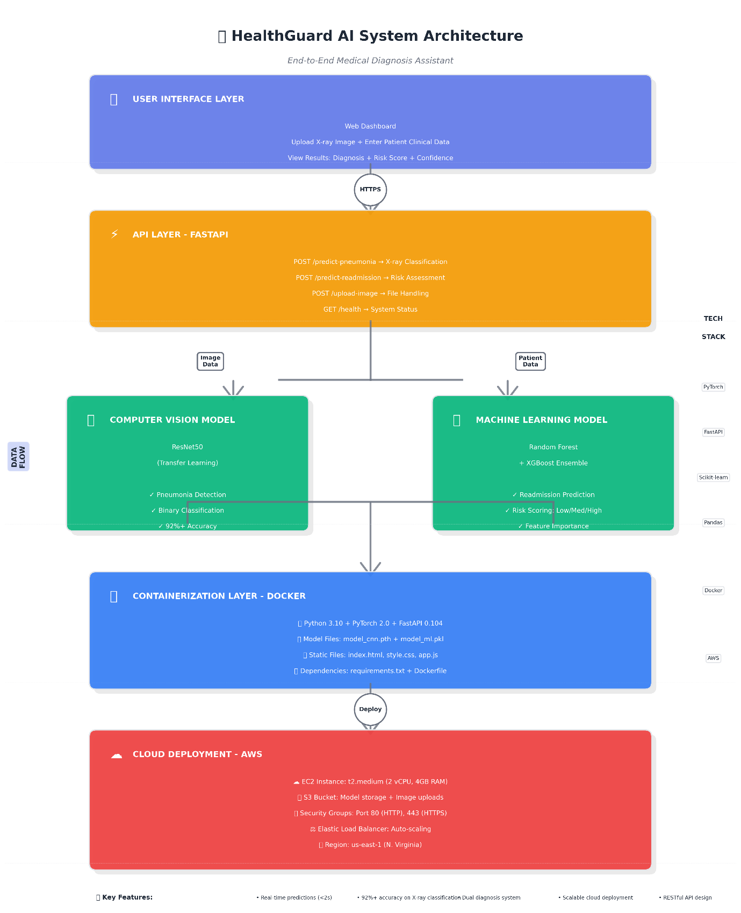

Key Features
- Dual Diagnosis: X-ray classification + Clinical risk assessment
- Real-time Predictions: < 2 seconds response time
- High Accuracy: 92%+ on X-ray classification
- Interpretable Results: Confidence scores + feature importance
- Scalable Deployment: Cloud-based for global access

Week Coverage: Weeks 3, 5-6, 10-11, 17-18, 20

4. PROJECT OPTION 2

💰 SmartInvest AI - Stock Price Prediction & Portfolio Optimizer

Problem Statement
Individual investors and small trading firms struggle to make data-driven investment decisions due to the complexity of financial markets and lack of sophisticated analytical tools. Stock price volatility, financial news impact, and portfolio optimization require advanced capabilities.
Key Challenges:
- Stock price volatility makes prediction extremely difficult
- Financial news impacts market sentiment but is hard to quantify
- Portfolio optimization requires complex mathematical calculations
- Retail investors lack access to institutional-grade tools
- Manual analysis is time-consuming and often emotionally biased

Solution Overview
SmartInvest AI combines time-series forecasting and NLP:
- Price Forecasting: LSTM neural networks for 7-day and 30-day predictions with technical indicators
- Sentiment Analysis: FinBERT model for financial news (Bullish/Neutral/Bearish classification)
- Portfolio Optimization: Modern Portfolio Theory (Markowitz) with efficient frontier visualization
- Interactive Dashboard: Real-time stock data from Yahoo Finance API with Plotly charts

Tech Stack
Component | Technology | Course Week
Time Series Forecasting | PyTorch LSTM, GRU | Week 12
Sentiment Analysis | HuggingFace BERT (FinBERT) | Week 13
Portfolio Optimization | Scikit-learn, PyPortfolioOpt | Week 5-7
Data Collection | yfinance API, NewsAPI | Week 4
Data Processing | Pandas, NumPy | Week 3
Visualization | Plotly, Matplotlib | Week 3
API Framework | FastAPI | Week 17
Containerization | Docker | Week 18
Cloud Platform | AWS EC2, S3 | Week 20

System Architecture
Integrated AI components for comprehensive financial analysis:
1. Data Ingestion: Yahoo Finance API (5+ years historical data) + NewsAPI (real-time financial news)
2. Feature Engineering: Technical indicators (MA, EMA, RSI, MACD, Bollinger Bands) + Sentiment scores
3. Model Layer: LSTM for time series + FinBERT for sentiment + Markowitz optimization engine
4. API & Visualization: FastAPI endpoints + Plotly interactive charts (candlestick, trends, frontier)
5. Deployment: Docker on AWS EC2 with automated daily updates via scheduled jobs

Technical Architecture Diagram
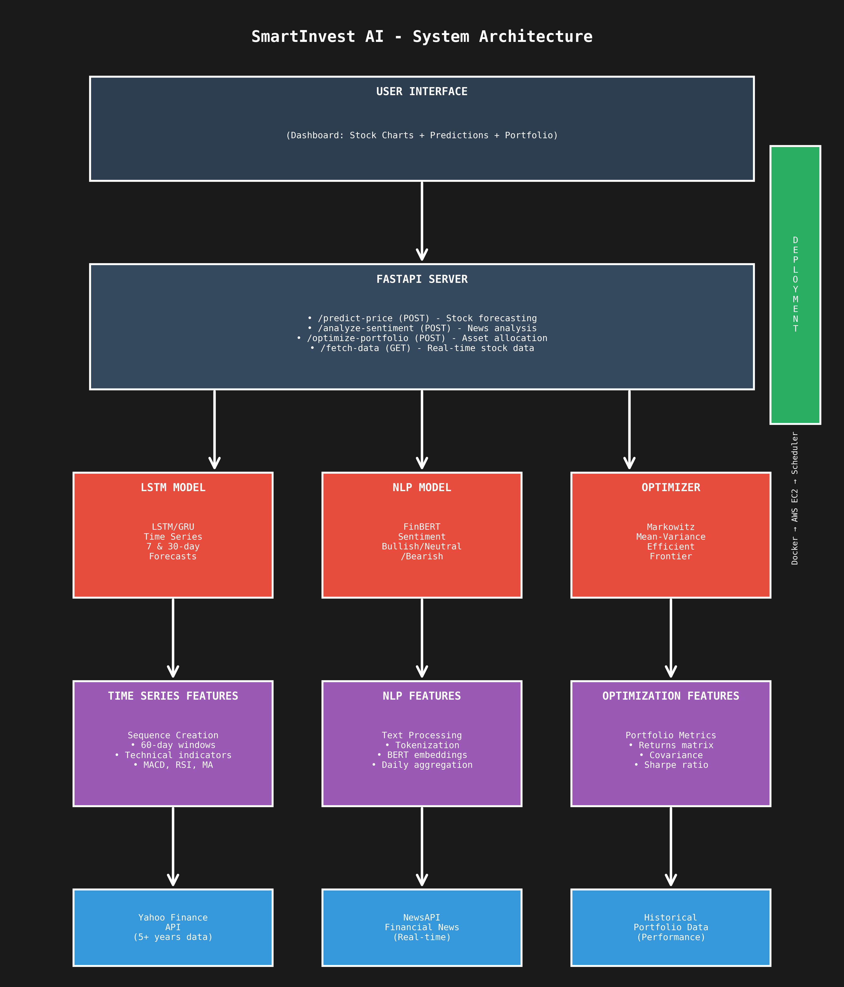

Key Features
- Multi-stock Tracking: Monitor 10+ stocks simultaneously
- Dual Timeframe Forecasts: 7-day and 30-day predictions
- Real-time Sentiment: Latest news impact analysis
- Risk Analysis: Portfolio volatility and Sharpe ratio calculations
- Efficient Frontier: Optimal asset allocation visualization

Week Coverage: Weeks 3-4, 5-7, 12-13, 17-18, 20

5. PROJECT OPTION 3

📝 SmartDocs AI - Intelligent Document Assistant

Problem Statement
Organizations and individuals deal with massive volumes of documents daily - research papers, company policies, legal contracts, technical manuals, and knowledge bases. Finding specific information is time-consuming, traditional keyword search misses semantic meaning, and knowledge is often siloed.
Key Challenges:
- Finding specific information across hundreds of documents takes hours
- Understanding complex technical or legal language requires expertise
- Traditional keyword search misses semantic meaning and context
- Manual document review can take hours or days
- Knowledge is siloed and not easily accessible to teams

Solution Overview
SmartDocs AI powered by RAG (Retrieval-Augmented Generation):
- Semantic Search: Vector embeddings with Sentence Transformers stored in ChromaDB
- Q&A System: LLM-powered responses (GPT-4/Llama 2) with source citations
- Multi-format Processing: PDF, DOCX, TXT with intelligent chunking (500-1000 tokens)
- Chat Interface: Conversational Q&A with conversation history and context retention

Tech Stack
Component | Technology | Course Week
LLM Integration | OpenAI GPT-4 / LangChain | Week 14
RAG Architecture | LangChain, ChromaDB | Week 15
Embeddings | Sentence Transformers (all-MiniLM-L6-v2), HuggingFace | Week 13
Document Processing | PyPDF2, pdfplumber, python-docx | Week 3
Vector Database | ChromaDB | Week 15
API Framework | FastAPI | Week 17
Containerization | Docker | Week 18
Cloud Platform | AWS EC2, S3 | Week 20

System Architecture
RAG-based architecture with dual-path processing:
Upload Path: Document upload → Text extraction → Chunking → Embedding (384 dims) → ChromaDB storage
Query Path: User question → Query embedding → Similarity search (Top-K=5) → LLM generation with context → Answer + citations
Document Processing: PyPDF2 for PDFs, python-docx for Word, with metadata (document name, page numbers, timestamps)
Generation Layer: GPT-4 or Llama 2 with prompt engineering (Context + Query + Instructions)
Interface: Chat UI (Streamlit/React) + FastAPI backend with document upload and query endpoints

Technical Architecture Diagram
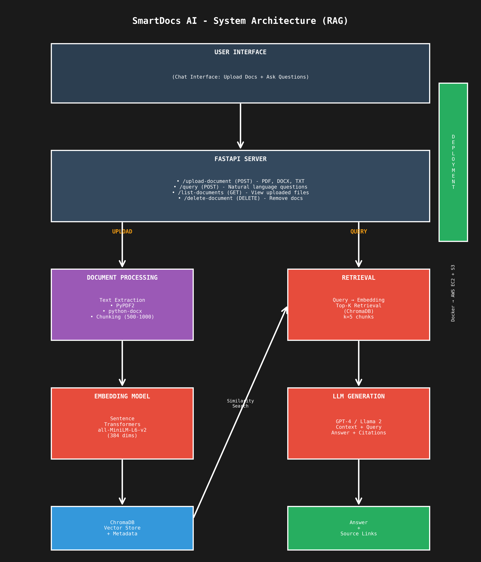

Key Features
- Multi-format Support: PDF, DOCX, TXT files
- Semantic Search: Understand meaning, not just keywords
- Source Citations: Always show where answers come from
- Conversation Memory: Follow-up questions with context
- Fast Retrieval: Sub-second search across thousands of documents

Week Coverage: Weeks 3, 13-15, 17-18, 20

6. PROJECT OPTION 4

🛒 ShopSmart AI - E-Commerce Recommendation Engine

Problem Statement
E-commerce platforms struggle with poor product discovery and generic recommendations, leading to significant revenue loss. Customers spend excessive time searching, cart abandonment exceeds 70%, visual search is limited, and customer support cannot handle complex queries at scale.
Key Challenges:
- Customers spend excessive time searching for relevant products
- Generic recommendations fail to capture individual preferences
- Cart abandonment rates exceed 70% due to poor shopping experience
- Visual search capabilities are limited or non-existent
- Customer support cannot handle complex product queries at scale

Solution Overview
ShopSmart AI combines recommendation systems, computer vision, and AI agents:
- Personalized Recommendations: Hybrid system combining collaborative filtering (SVD) and content-based filtering (TF-IDF)
- Visual Search: CNN embeddings (ResNet/EfficientNet) with FAISS for image-based product search
- Shopping Assistant: Multi-agent workflow (LangGraph) for natural language product queries
- Complete Platform: User profiles, purchase history, real-time inventory, and analytics dashboard

Tech Stack
Component | Technology | Course Week
Collaborative Filtering | Scikit-learn (SVD), Surprise library | Week 6
Content-Based Filtering | TF-IDF, Cosine Similarity | Week 5
Visual Search | PyTorch ResNet, EfficientNet + FAISS | Week 10-11
AI Agents | LangGraph, LangChain | Week 16
Clustering | K-Means (customer segmentation) | Week 7
Data Processing | Pandas, NumPy | Week 3
API Framework | FastAPI | Week 17
Containerization | Docker | Week 18
Cloud Platform | AWS EC2, S3 | Week 20

System Architecture
Multi-component intelligent recommendation system:
1. Data Layer: Product catalog (~50K products) + User-item interaction matrix + Product images + Customer reviews
2. Recommendation Engine: Collaborative filtering (SVD matrix factorization) + Content-based (TF-IDF + cosine similarity) + Hybrid weighted combiner
3. Visual Search: ResNet50 feature extraction + FAISS for fast nearest neighbor search
4. AI Agent Layer: LangGraph multi-agent workflow (Query Understanding → Search → Compare → Recommend)
5. Deployment: FastAPI backend + React frontend + Docker on AWS EC2 with S3 for product images

Technical Architecture Diagram
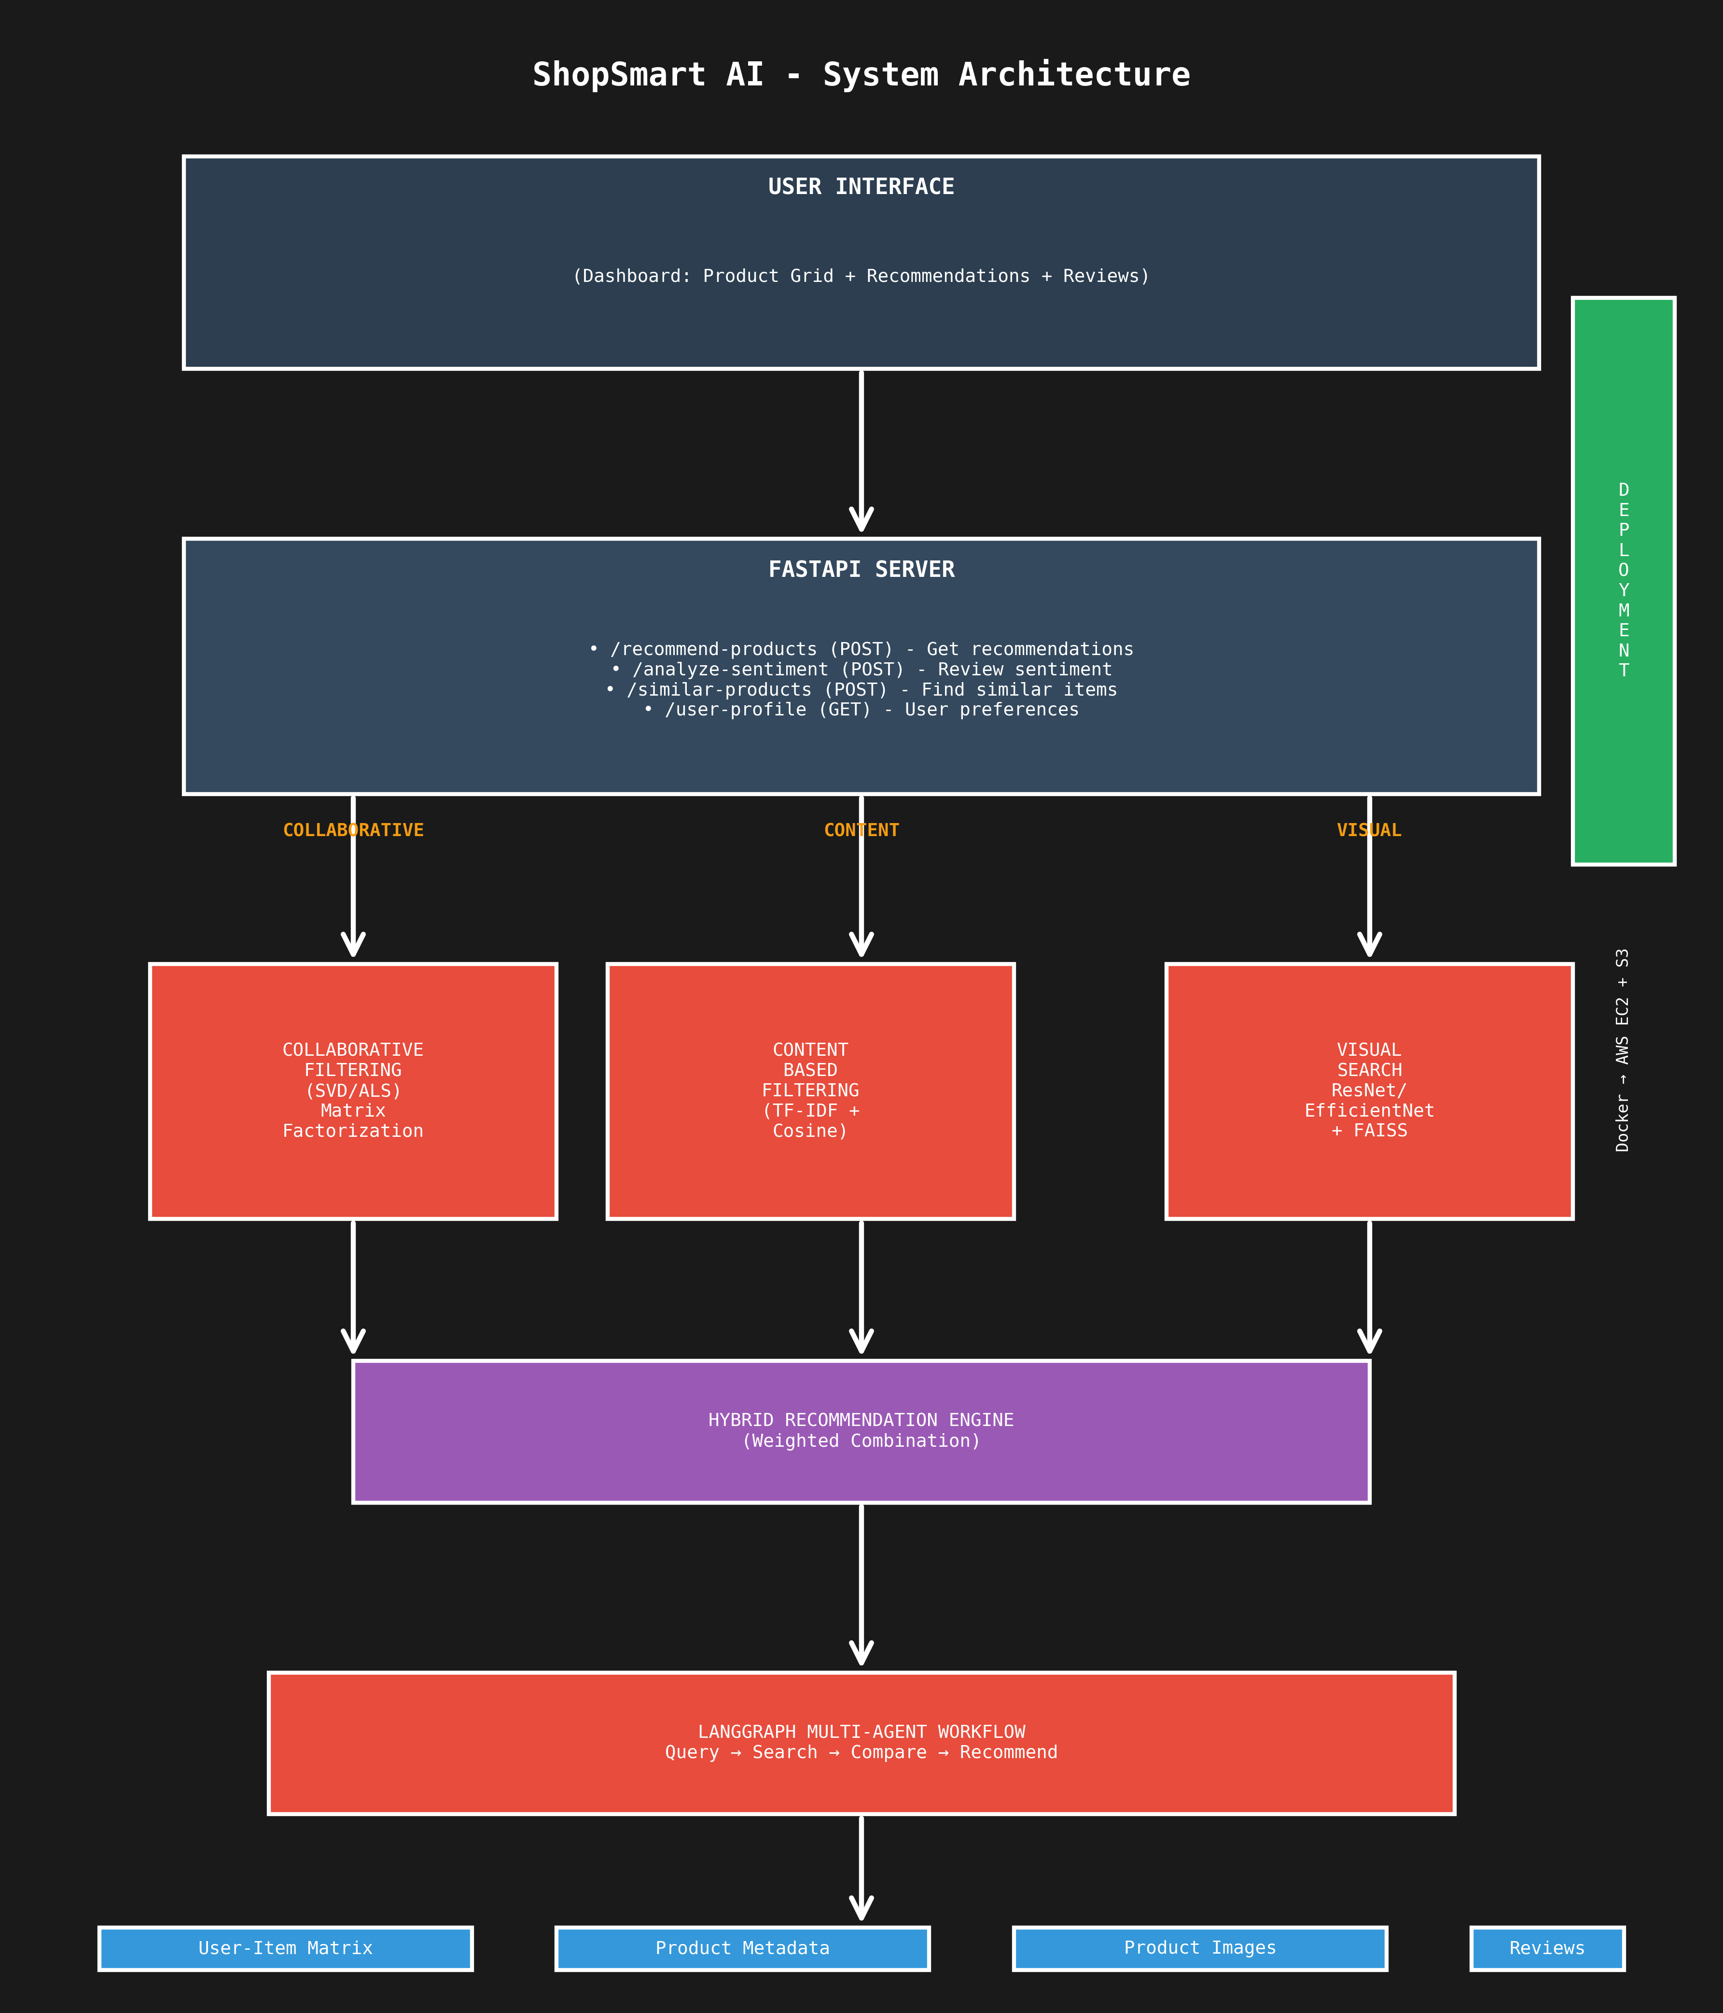

Key Features
- Hybrid Recommendations: Best of collaborative and content-based filtering
- Visual Search: Find products by uploading images
- Smart Chat Agent: Natural conversation for product discovery
- Customer Segmentation: K-Means clustering for targeted marketing
- Real-time Updates: Live inventory and price tracking

Week Coverage: Weeks 3, 5-7, 10-11, 16-18, 20

7. PROJECT COMPARISON MATRIX
Aspect | HealthGuard | SmartInvest | SmartDocs | ShopSmart
Domain | Healthcare | Finance | Enterprise | E-Commerce
Primary Focus | Computer Vision + ML | Time Series + NLP | RAG + LLMs | Recommendations + Agents
Data Type | Images + Tabular | Time Series + Text | Documents (PDF, DOCX) | Tabular + Images
Main Models | CNN, Random Forest | LSTM, BERT | LLMs, Embeddings | SVD, CNN, LangGraph
Best For Career | CV Engineer | Financial ML Engineer | LLM Engineer | Full Stack AI Engineer
Dataset Size | ~112K images + 100K records | 5+ years stock data | User-uploaded docs | ~50K products + reviews
Training Time | 2-4 hours (with GPU) | 1-2 hours | No training required | 1-3 hours

CONCLUSION
All four projects are designed to be equally challenging and comprehensive, with each focusing on different AI domains and technologies. Choose the project that best aligns with your career goals and technical interests.

Key Success Factors:
- Follow the week-by-week implementation plan
- Document your code and architecture thoroughly
- Test each component before integration
- Deploy to cloud for real-world accessibility
- Prepare a professional presentation and demo

Good luck with your capstone project! 🚀
AI Bootcamp Team
Module VI: Capstone Projects

